1. What is Unit testing and why do we need it?
2. Unit testing is where we test our code at a unit or class level. That is we test all the public methods on a class. We will do this by providing different types of values to methods and see if the methods behave as expected both positive as well as exception scenarios.

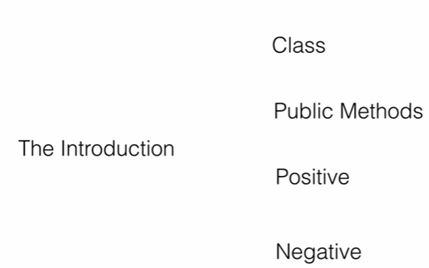

1. Let’s consider an order processing application where we have order processor class with two methods in it.
2. 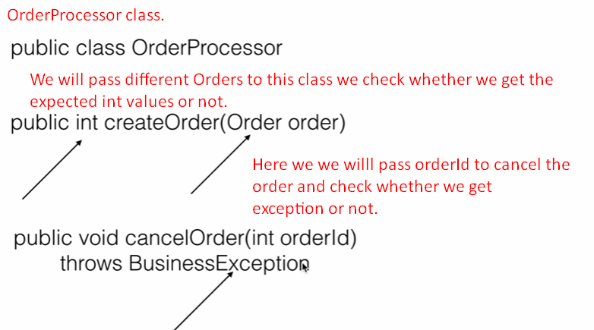
3. 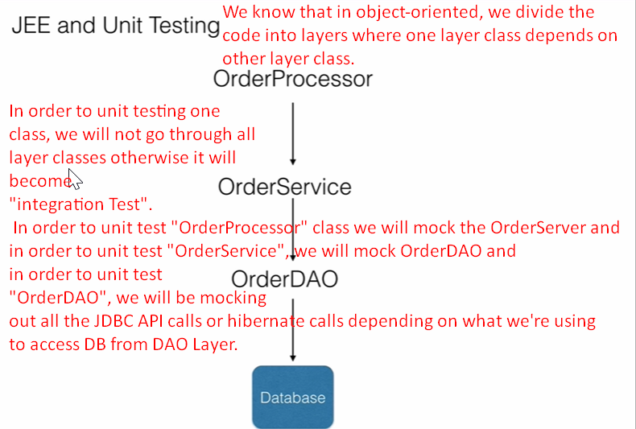
4. **Advantages**:  
   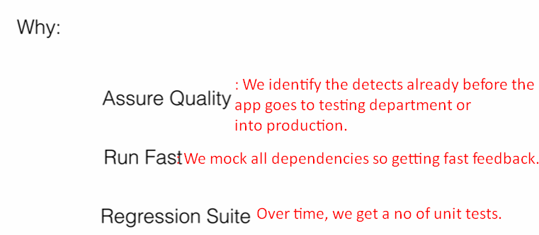
   1. **Assure Quality:** When we write unit tests, we catch the defects during development time and the no of defects during testing or in production goes down thus improving the quality of the product.
   2. **Run Fast:** Since we mock out every dependency to the unit/class we want to test and we test the class on its own, the tests run very fast and gives instant feedback. This is because there is no database call or webservice call as we’re mocking out all those calls. We can run these tests right out of IDE without any additional setup.
   3. **Regression Suite:** Over time, as we write these unit tests, they will become a regression suite. That is if we or some other developer is making a small change to a part of an application, we can update the current unit test as well as we can run already existing unit tests for the product to ensure nothing already running parts don’t break due to this new change.
5. 